FOR IMMEDIATE RELEASE CONTACT: Kim Ina
swc@swcfoundation.org
(415) 566-3487

SPORTS FOR THE WORLD’S CHILDREN TO HOST 14TH ANNUAL
“THEY ARE WORTHY” BENEFIT SOFTBALL TOURNAMENT

SAN FRANCISCO, April 8, 2011 – The Sports for the World’s Children Foundation (SWC) will host its 14th annual “They Are Worthy” benefit softball tournament the weekend of July 9 & 10 at Westlake Park in Daly City. Participants are encouraged to bring gently used and new sports equipment to support their youth programs locally and abroad. All donated equipment and proceeds from the tournament go to providing kids (and communities and schools) with much needed sports equipment, facilities, skills clinics, and mentoring programs. Equipment accepted includes baseballs, bases, basketballs, bats, batting gloves, Frisbees, mitts, soccer balls, sports trading cards, sports uniforms (at least five alike), volleyballs, volleyball nets, etc. Entry forms can be found at www.swcfoundation.org.

Tournament format will be round robin and/or double elimination for the coed division(s), and men’s division(s), depending on final number of entries. Two games are always guaranteed. Prizes include T-shirts for championship teams, All Star prizes, and many others.

Last year a total of 14 teams participated in the four divisions of the tournament, and participants donated hundreds of pounds of sports equipment. The equipment was later transported to communities and programs in need, both locally and abroad, through SWC’s “Communities Play” equipment distribution program. Most recently, SWC provided much needed equipment to the following programs:

- A youth program (The Heritage After School Program), serving at-risk boys and girls, ages 11 through 14, based in Illinois. Equipment provided included basketballs, footballs, softballs, softball and baseball bats, and volleyballs.

- A little league baseball “school” (Flavio Torres) in La Paz, Baja California Sur, Mexico.

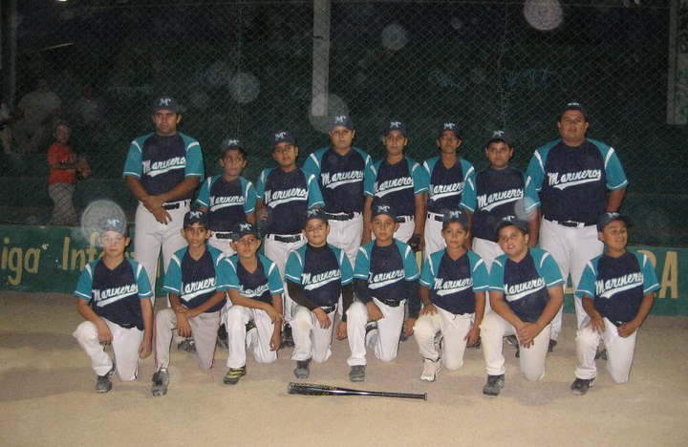

- A girls’ softball program (Predator Softball) under the Youth Centers of America that serves/targets females, ages 6 through 16, from low income families in Parlier, California. Equipment provided included catcher equipment (helmets, chest protectors, leg guards), batting helmets, softballs, gloves/mitts, bases, batting tees, and equipment bags.

The Sports for the World’s Children Foundation (SWC), based in San Francisco, is a long time supporter of youth participation in sports both locally and abroad. SWC’s mission is to facilitate the creation of ongoing, self-sustaining, quality sports programs for children with limited or no resources. Over the past thirteen years, SWC has benefited more than 16,050 children, ages 5-18, by providing them with thousands of pounds of sports equipment and sports skills instruction and training through its “Communities Play” Program. SWC’s “Communities Play” Program has received past support from Alaska Airlines, Major League Baseball’s Baseball Tomorrow Fund, and the Kristi Yamaguchi Always Dream Foundation.

Interested individuals, teams, and/or sponsors can contact SWC for more information about the benefit softball tournament, their “Communities Play” sports equipment distribution/volunteer program abroad, and/or to receive a DVD about their sports equipment distribution/volunteer programs abroad at swc@swcfoundation.org, (415) 566-3487.

# # #

